**Creating animation using photoshop**

A GIF (Graphics Interchange Format) is a type of image file that supports both static and animated images. Developed by CompuServe in 1987, it uses a lossless compression technique called Lempel-Ziv-Welch (LZW) to reduce file size without losing image quality. GIFs can display up to 256 colors and support transparency, allowing for images with see-through backgrounds. Their ability to store multiple frames in a single file enables simple animations, which typically loop endlessly. Because of their small size and ease of use, GIFs are popular for sharing short, looping animations and simple graphics on the internet.

Procedure

**Step 1:**

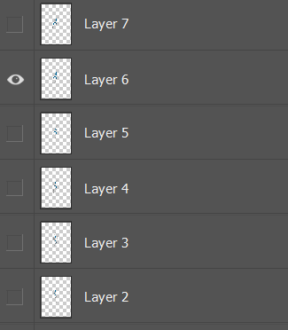Select an image and create a couple of layers of it.

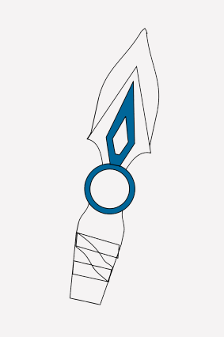

**Step 2:**

Create animation frame by frame as per your need.

Like I am doing knife rotate animation, so I am rotating my object frame by frame.

Ctrl + t to select object and rotate it.(do for every frame)

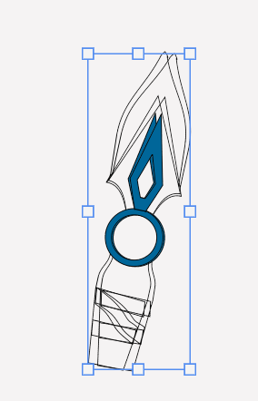

**Step 3:**

Menu the window -> timeline (to create timeline)

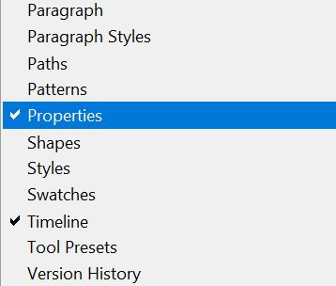Time line will show up at the bottom of the screen.

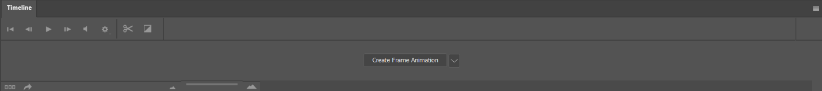

**Step 4:**

Click on create frame animation.

And click on menu at right of time line -> make frame from layers

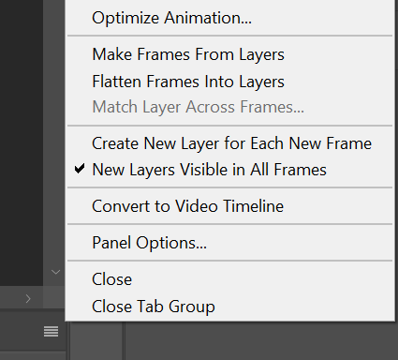

Now your time line should look like this.

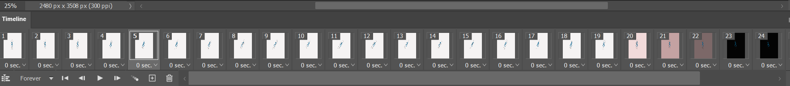

**Step 5:**

Adjust frame rate by selecting all the frames.

(0.2)

If necessary, edit there in animation.

**Step 6:**

**Export as gif.**

**Menu -> File -> Export -> Save for web(legacy)**

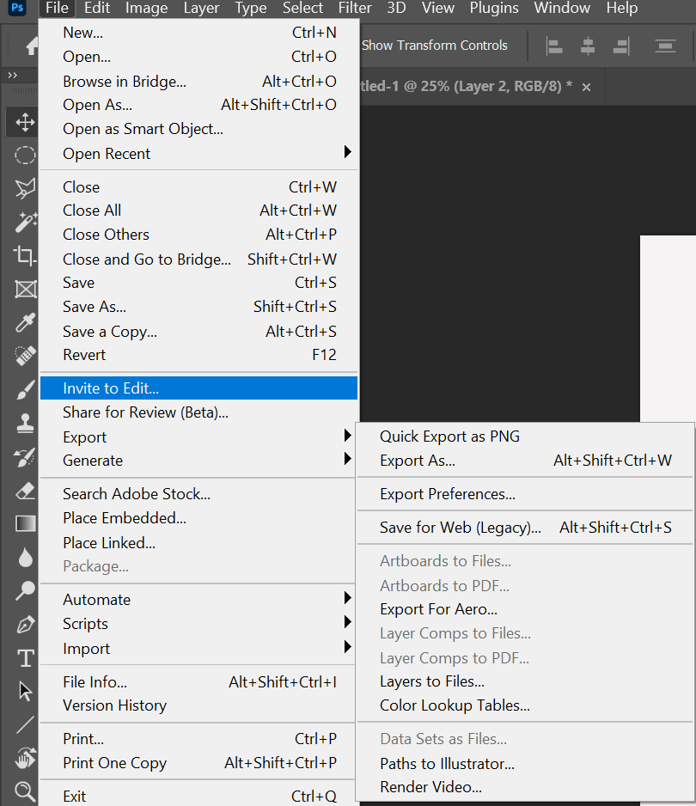

If done correctly then this window will pop up.

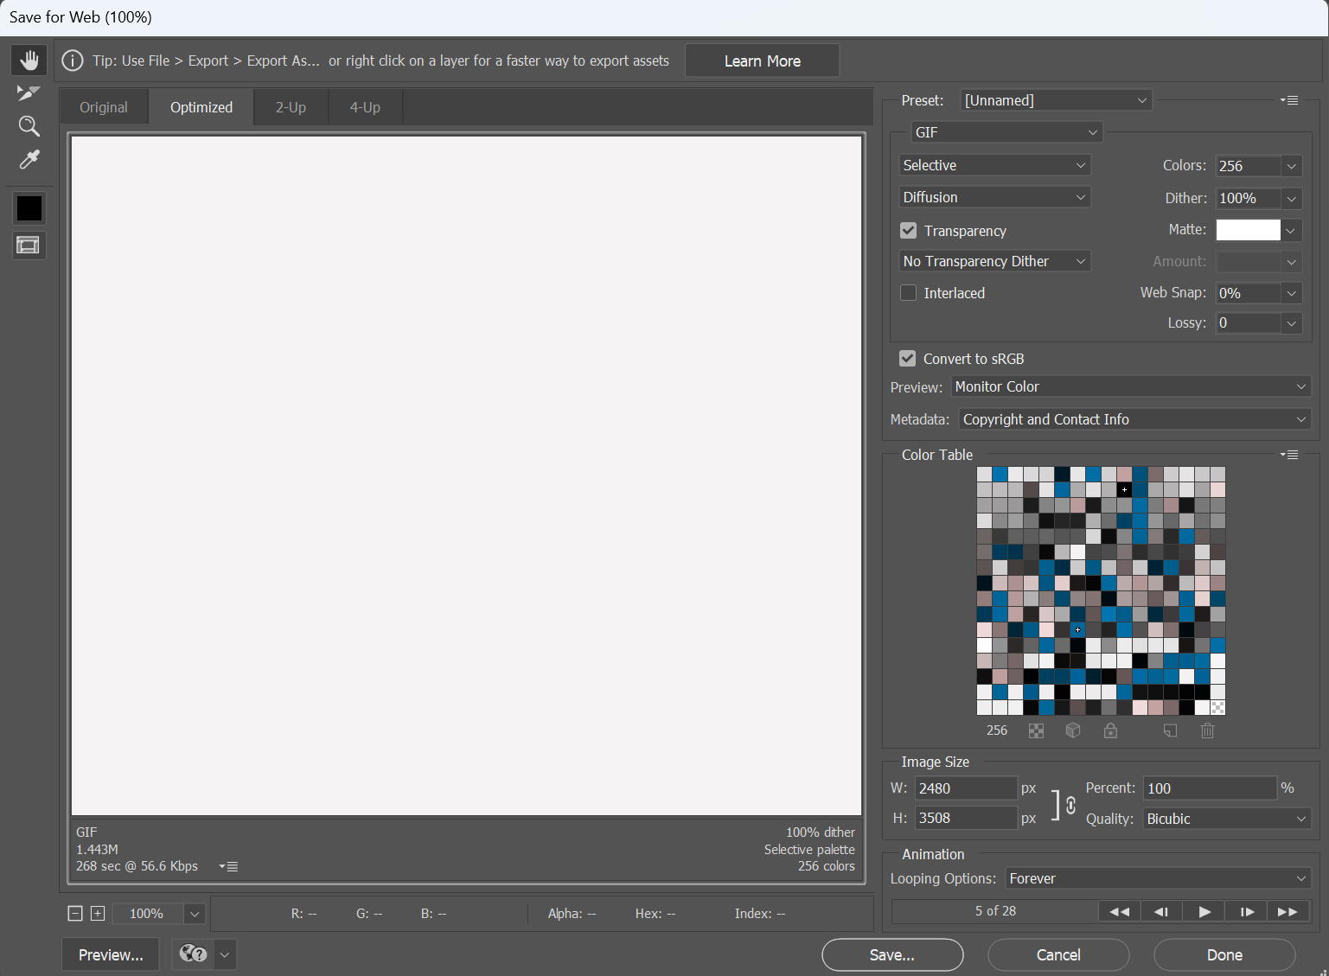

Adjust according to your need and save the file.

Conclusion:

Creating a GIF in Photoshop allows for high-quality, detailed animations with precise control over each frame. The process involves importing images or video, arranging frames, setting durations, and exporting the final GIF. This method ensures versatile and widely-compatible GIFs, suitable for various platforms and uses. Photoshop's powerful tools enable creative enhancements, making it an excellent choice for professional and high-quality GIF creation.